Test 1
clean_session = True
publisher and subscriber QOS = 0
Expected result: No messages received as the broker shouldn’t store them
Actual results: The subscriber receives the messages ONLY IF running while the publisher sends the message.
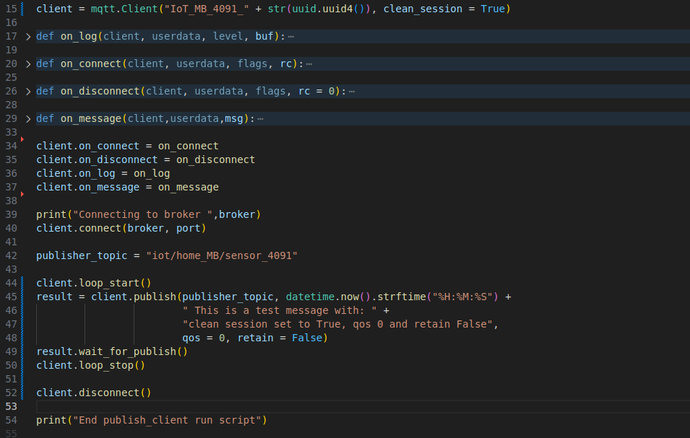
Publisher code:
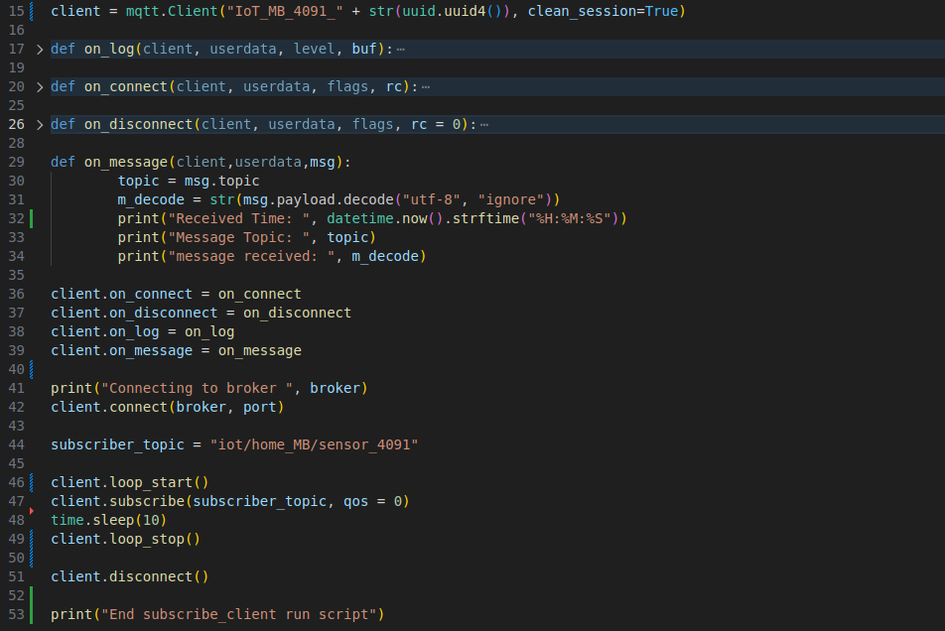
Subscriber code:

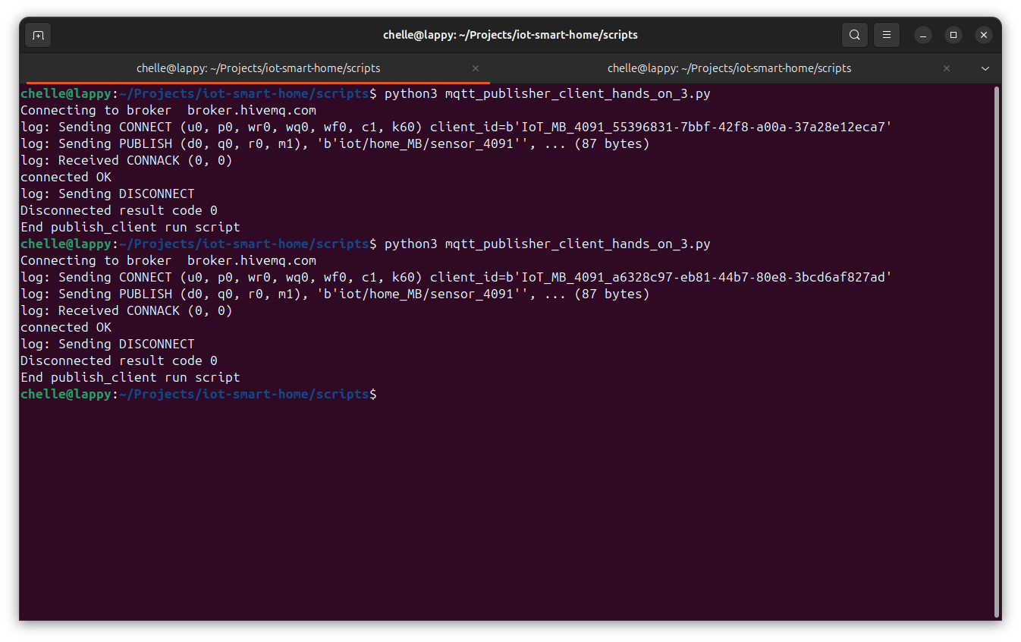
Publisher run:
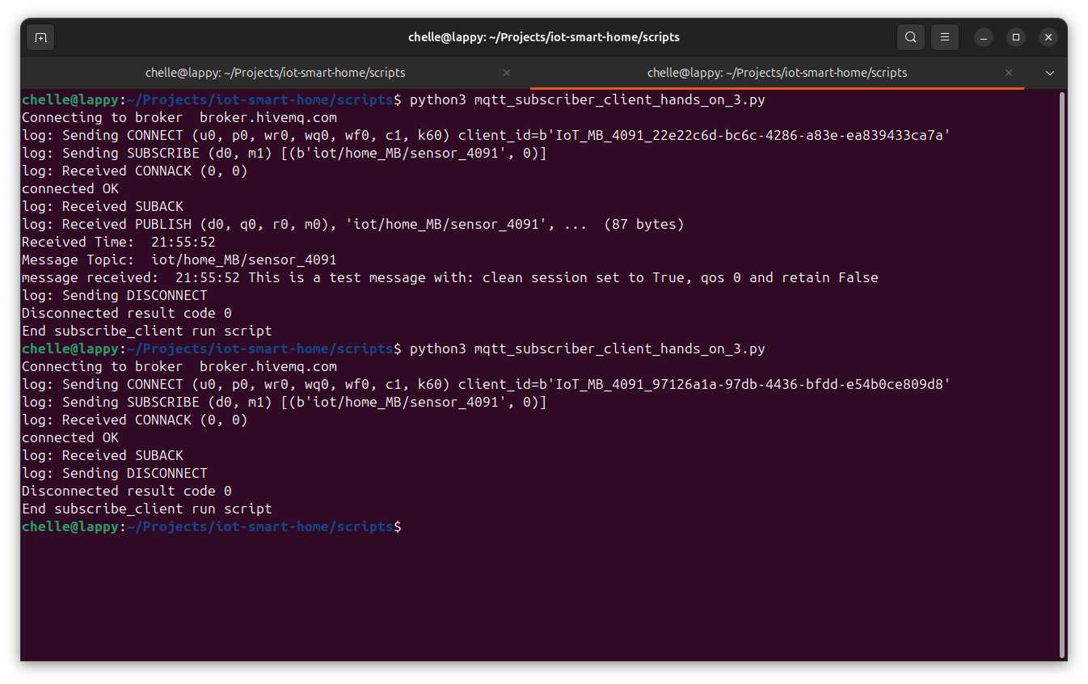
Subscriber run:
On the first run the subscriber was ran before the publisher and received the message sent by the publisher.
On the second run the publisher was ran AFTER the publisher and didn’t receive the message since it wasn't retained by anyone.

